COS225 Assignment #7 Name ___________________________
Due: Fri 3/30/18
Late: Fri 4/8/18
Readings: Chapter 18

Create a Word or RTF or PDF document (no other formats please) with answers to Part I questions and screen shots of program output.

Part I: (20 pts.)

Use the following method for the next two questions.

public static int mystery (int x)
{ if (x == 1) return 1;
else return 5 * mystery (x-1);
}

1. (2) What is the result from the call: mystery (3)?

___________________________________________

2. (2) The base case occurs when the parameter has value(s) ________________.

a. 0 b. 1
c. greater than 1 d. greater than or equal to 1

3. (4) What is the output of the program below?

public static void main(String [ ] args)
{ int [ ] a = { 10, 20, 30 , 40 };
mystery (a, 4, 3);
for (int k=0; k<4; k++)
System.out.print (a[k] + " ");
}
public static void mystery (int a[ ], int n, int m)
{ if ( m == -1) return;
else
{ a[m] = a[m] * 2;
mystery(a,n,m-1); }
}

__________________________________________________________________

4. (2) Which statement is not true about the recursive Fibonacci function seen below?

public static int fib (int n)
{ if (n <= 2) return 1;
else return fib(n-1) + fib (n-2);
}

a. The result of fib(4) is fib(2) + fib(3).
b. This function has multiple base cases.
c. This function can yield infinite recursion similar to an infinite loop.
d. This function is slow when passed a large value of n due to the double recursive calls.

Consider a recursive method that is passed a non-negative integer base and exponent and returns the base raised to the exponent.

int power (int base, int exp)
// PRE: base, exp >= 0
// POST: return base^{exp}

5. (2) What is the value of power (2,0)?

a. 0 b. 1 c. 2 d. 4 e. this call will cause heap overflow

6. (2) What is the value of power (2,3)?

a. 0 b. 4 c. 8 d. 16 e. this call will cause heap overflow

7. (6) Complete the recursive power method.

int power (int base, int exp)
// PRE: base, exp >= 0
// POST: return base^{exp}
{

}

Part II: (80 pts.)
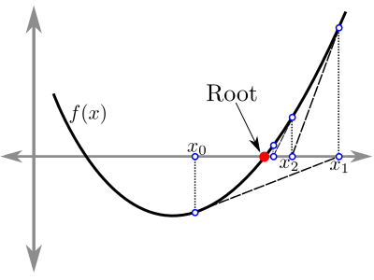
Ex. The problem of finding the roots of a real-valued function occurs frequently in mathematics. If f(x) is a function, a root r of f( ) is a real number such that f(r) = 0. In some cases with quadratic functions, roots can be computed directly using the quadratic equation. In general, roots can be found using approximation methods. If f(a) and f(b) are of opposite sign (f(a) * f(b) < 0) and f is well-behaved (continuous and differentiable), then there is a root r between a and b.

Quadratic Equation:
Given equation: ax² + bx + c = 0 where a, b, and c are integers, the roots may be computed if the determinant is not negative.
_______ _______
x = -b + √b² – 4ac x = -b - √b² – 4ac
2a 2a

Bisection Approximation Algorithm:
Let m = (a + b)/2 be the midpoint of the interval a < x < b.
If f(m) = 0.0 then m is a root.

If not, then either:
- f(a) and f(m) have opposite signs (f(a) * f(m) < 0) and root r lies in the interval a < x < m
- f(m) and f(b) have opposite signs (f(m) * f(b) < 0) and root r lies in the interval m < x < b

Perform the same process over with the new interval until the root is found exactly or the interval is reduced to an acceptable quantity for an approximation. This solution can be done iteratively or via recursion. The example below finds roots of equation x³ – 2x – 3 between the interval [1 .. 2] showing the values at each iteration.

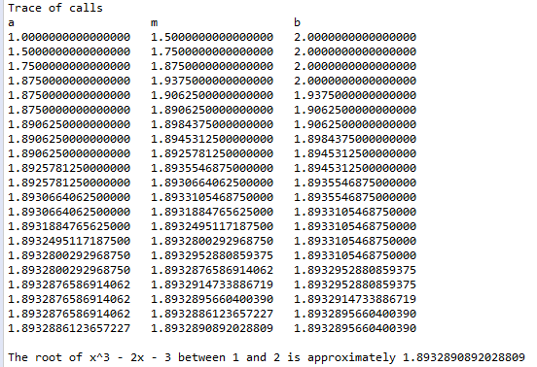
1. Use the MathFunction interface and MyFunction class. Add an additional constructor to the MyFunction class to construct an object using an argument of interface List. Using this base interface, the method can receive an object of any type that implements List, such as ArrayList or LinkedList.

public MyFunction (List<Double> coefficients) // POST: fill array with coefficient values

2. Design a BisectMethods class containing two static bisection methods, one iterative and one recursive. The user passes in the function, lower and upper bounds.

public static double ibisect (MyFunction function, double lower, double upper)
// PRE: root exists in [lower .. upper]
// POST: return approximate root using iterative algorithm with precision 0.000000000001

public static double rbisect (MyFunction function, double lower, double upper)
// PRE: root exists in [lower .. upper]
// POST: return approximate root using recursive algorithm with precision 0.000000000001

3. Write an interactive application in which the user is asked the number of functions followed by their coefficients and interval bounds. Use the MyFunction class. For simplicity, assume there is a root between the upper and lower bounds. For each function, report the following information. Be sure to call both iterative and recursive algoirthms for comparison. The first line of output is your name.

root using the quadratic equation (if possible)
or
approximate root using an iterative bisection technique
and
approximate root using a recursive bisection technique

3. Turn in the following run on the following four equations.

f(x) = x² -5x-24 on interval [5..10]
f(x) = x³-2x-3 on interval [1..2]
f(x) = x²-2x-8 on interval [-4..0]
f(x) = x³-4 on interval [0..2]

4. Submit the .jar file of source code as well as a screen shot of output.

